D.A.V. Public School BARIATU Ranchi

[Assignment / 8th Board / 2024-25]

Subject: Mathematics (Assignment No. 2)

***Short Answer Type Questions/3 Marks Each***

Q1) Three numbers are in the ratio 2:3:4. The sum of their cubes is 33957. Find the numbers.

Q2) If 4x – 4x-1  = 24, then find the value of x

Q3) If 3x-1 = 9 and 4y+2 = 64, find the value of $\frac{y}{x}$- $\frac{x}{y}$

Q4) A garrison of 120 men has provision for 30 days. At the end of five days, five more men joined them. How many days can they sustain on the remaining provision ?

Q5) Simplify : (a2 -b2)(a2 + b2) –(a2 -b2)2

Q6) If x2 + = 51, find the value of (x - $\frac{1}{x}$)

Q7) Find the sum of quotient and remainder, when (y3 +5y2 + 12y +9) is divided by (y+2).

Q8) Prove that the interior angle of a regular pentagon is three times the exterior angle of a regular decagon.

Q9) On a cartesian plane, draw a square ABCD, whose 3 vertices are A(2,3), B(5,3) and D(2,6). Find the coordinate of the vertex ‘C’. Also, find its area.

Q10) The perimeter of a trapezium is 104 m, its non parallel sides are 18 m and 22 m, and its altitude is 16 m. Find the area of trapezium.

Q11) Find the greatest number of six digits, which is a perfect square. Also find the square root of the resulting number.

Q12) Fctorise : (9m2 -30mn + 25n2 ) – 64x2

Q13) A train of 140 m lonǁg is running at a speed of 60 km/hr. How much time will it take to completely pass a platform 260 m long.

Q14) The price of different lengths of ladders in metres is shown in the following table.

|  |  |  |  |  |  |
| --- | --- | --- | --- | --- | --- |
| **Length of Ladder (in metre)** | 10 | 12 | 14 | 16 | 18 |
| **Price of the Ladder (in Rs)** | 700 | 850 | 900 | 1000 | 1050 |

Plot a graph (taking length of ladder on x-axis) to show this information.

Q15) In the given figure, l ǁ m and p ǁ q, find the value of x, y and z.

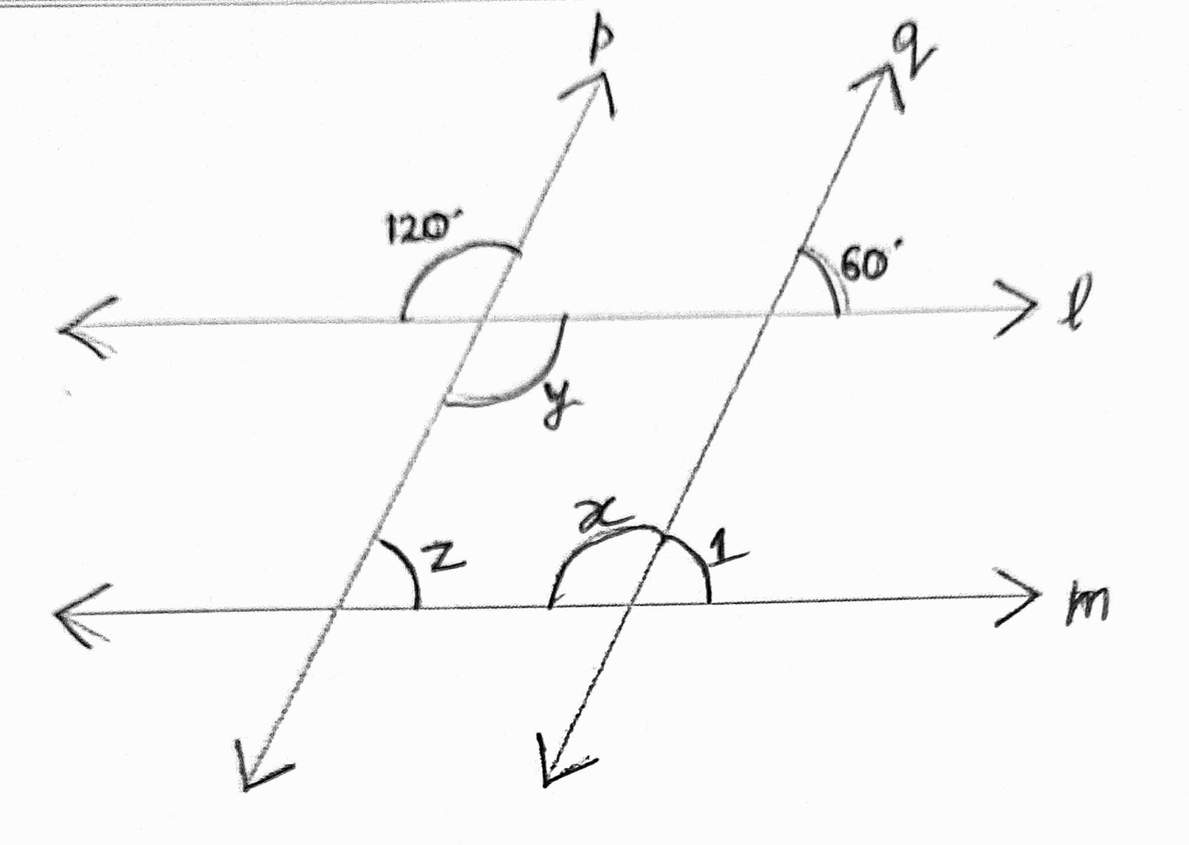

Q16) The length of a pair of adjacent sides of a rectangle are in the ratio 4 : 3. If its diagonal is of length 50 cm, find the lengths of the sides of the rectangle and hence find the perimeter of the rectangle.

Q17) Divide 225x – 125 – 135x² + 27x³ by 3x -5 to find the quotient and the remainder.

Q18) Find the square root of 5.462 correct to two decimal places.

Q19) In the given figure, the diagonals of rectangle NICE intersect each other at O. Find the value of x.

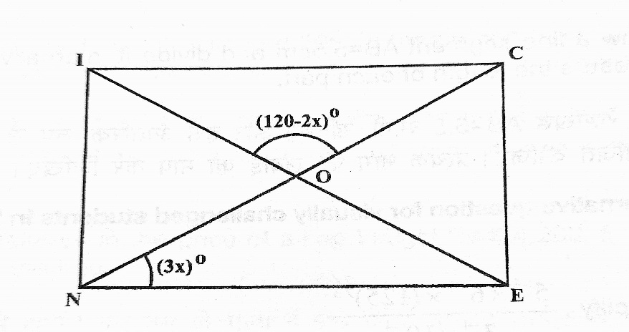

Q20) Draw a line segment AB =5.5 cm and divide it internally in the ratio 2:3. Measure the length of each part.

*************************